EXPERIMENTS

NAME:BHARANI DHARAN S
REG NO:192424141
COURSE CODE:DSA0602 DATA HANDLING AND VISUALIZATION

SET 3 – EMPLOYEE PERFORMANCE EVALUATION

DATASET
Employee ID | Department | Years of Service | Performance Score
1 | Sales | 5 | 85
2 | HR | 3 | 92
3 | Marketing | 7 | 78
4 | Sales | 4 | 90
5 | HR | 2 | 76

QUESTION 1
Create a line chart to visualize the performance trend of employees over time. Include a legend and labels.

AIM
To create a line chart in R to visualize the performance scores of employees based on their years of service.

PROCEDURE
- Create the employee dataset.
- Extract years of service and performance scores.
- Use the plot() function to create a line chart.
- Add suitable axis labels and title.
- Add a legend for the department.
- Run the program and observe the graph.
CODE

employee <- data.frame(
Employee_ID = c(1, 2, 3, 4, 5),
Department = c("Sales", "HR", "Marketing", "Sales", "HR"),
Years_of_Service = c(5, 3, 7, 4, 2),
Performance_Score = c(85, 92, 78, 90, 76)
)

plot(employee$Years_of_Service,
employee$Performance_Score,
type = "o",
xlab = "Years of Service",
ylab = "Performance Score",
main = "Employee Performance Trend",
pch = 16)

text(employee$Years_of_Service,
employee$Performance_Score,
labels = employee$Department,
pos = 3)

legend("topright",
legend = unique(employee$Department),
pch = 16)

OUTPUT

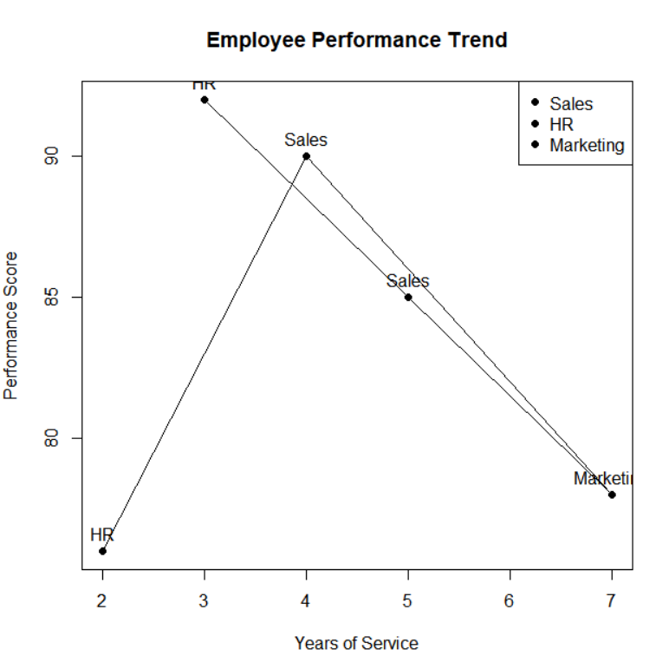

RESULT
Thus, the employee performance trend was successfully visualized using a line chart in R.

QUESTION 2
Generate a bar chart showing the distribution of employees across different departments. Label the chart elements.

AIM
To create a bar chart showing the number of employees in each department.

PROCEDURE
- Create the employee dataset.
- Count the employees in each department.
- Use the barplot() function.
- Add title and axis labels.
- Display the employee count on each bar.
- Run the program.

CODE
employee <- data.frame(
Employee_ID = c(1, 2, 3, 4, 5),
Department = c("Sales", "HR", "Marketing", "Sales", "HR"),
Years_of_Service = c(5, 3, 7, 4, 2),
Performance_Score = c(85, 92, 78, 90, 76)
)

dept_count <- table(employee$Department)

barplot(dept_count,
main = "Employees by Department",
xlab = "Department",
ylab = "Number of Employees")

text(seq_along(dept_count),
dept_count,
labels = dept_count,
pos = 3)

OUTPUT

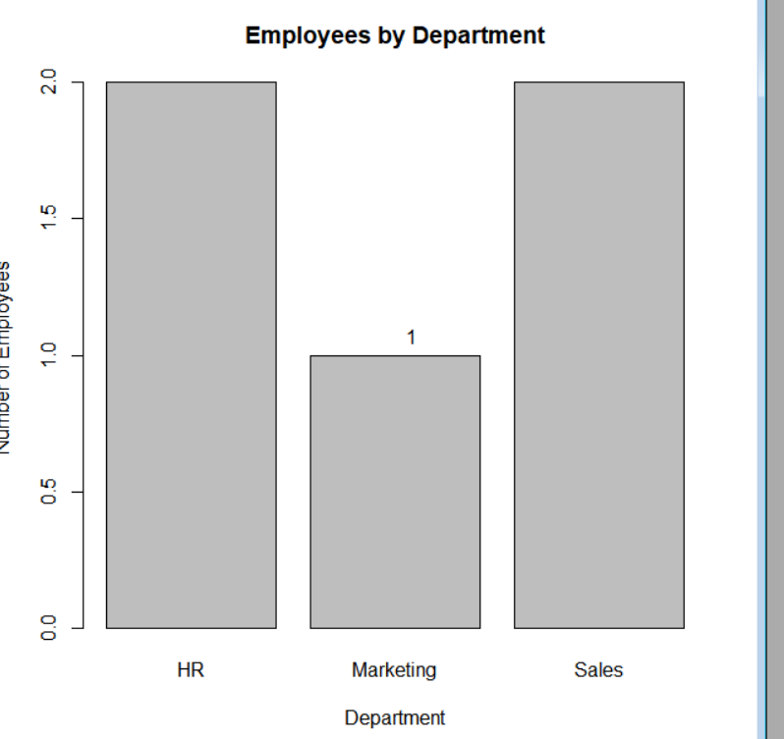

RESULT
Thus, the distribution of employees across different departments was successfully represented using a bar chart in R.

QUESTION 3
Build a scatter plot to analyze the correlation between years of service and performance scores. Explain any insights.

AIM
To create a scatter plot and analyze the relationship between years of service and performance scores.

PROCEDURE
- Create the employee dataset.
- Select years of service and performance score.
- Use plot() to create a scatter plot.
- Calculate the correlation using cor().
- Add suitable labels and title.
- Run the program and observe the relationship.

CODE
employee <- data.frame(
Employee_ID = c(1, 2, 3, 4, 5),
Department = c("Sales", "HR", "Marketing", "Sales", "HR"),
Years_of_Service = c(5, 3, 7, 4, 2),
Performance_Score = c(85, 92, 78, 90, 76)
)

plot(employee$Years_of_Service,
employee$Performance_Score,
main = "Years of Service vs Performance Score",
xlab = "Years of Service",
ylab = "Performance Score",
pch = 19)

correlation <- cor(employee$Years_of_Service,
employee$Performance_Score)

print(correlation)

OUTPUT

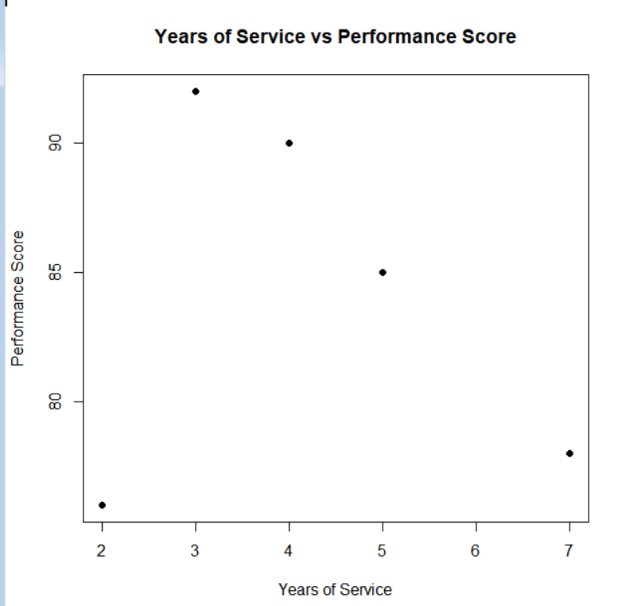

RESULT
Thus, the correlation between years of service and performance score was successfully analyzed using a scatter plot. For this dataset, the correlation is approximately -0.17, indicating a weak negative linear relationship.

QUESTION 4

Develop a Tableau dashboard with the line chart and bar chart for interactive exploration.

AIM
To create an interactive Tableau dashboard by combining the employee performance line chart and department bar chart.

PROCEDURE
- Open Tableau.
- Create the employee dataset in Excel or CSV format.
- Connect the dataset to Tableau.
- Create a Line Chart worksheet using Years of Service and Performance Score.
- Create a Bar Chart worksheet using Department and Employee ID.
- Create a new Dashboard.
- Drag both worksheets into the dashboard.
- Add filters for Department and Employee ID.
- Save and run the dashboard.

CODE
library(shiny)

employee <- data.frame(
Employee_ID = c(1, 2, 3, 4, 5),
Department = c("Sales", "HR", "Marketing", "Sales", "HR"),
Years_of_Service = c(5, 3, 7, 4, 2),
Performance_Score = c(85, 92, 78, 90, 76)
)

ui <- fluidPage(
titlePanel("Employee Performance Evaluation Dashboard"),

sidebarLayout(
sidebarPanel(
selectInput("department",
"Select Department:",
choices = c("All", unique(employee$Department)),
selected = "All")
),

mainPanel(
plotOutput("lineChart"),
plotOutput("barChart")
)
)
)

server <- function(input, output) {

filtered_data <- reactive({
if (input$department == "All") {
employee
} else {
employee[employee$Department == input$department, ]
}
})

output$lineChart <- renderPlot({
data <- filtered_data()

plot(data$Years_of_Service,
data$Performance_Score,
type = "o",
pch = 16,
xlab = "Years of Service",
ylab = "Performance Score",
main = "Employee Performance Trend")
})

output$barChart <- renderPlot({
data <- filtered_data()

department_count <- table(data$Department)

barplot(department_count,
main = "Employees by Department",
xlab = "Department",
ylab = "Number of Employees")
})
}

shinyApp(ui = ui, server = server)

OUTPUT

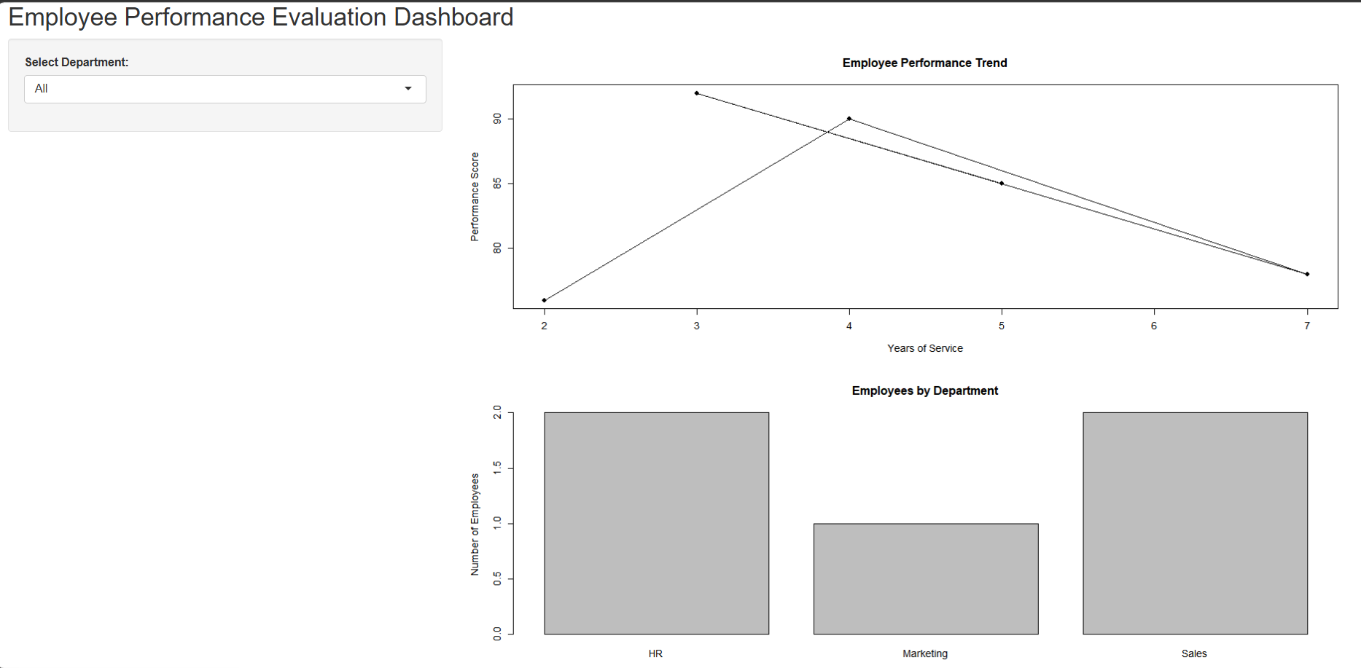

RESULT
Thus, an interactive employee performance dashboard was successfully developed in R using Shiny, combining a line chart and bar chart with department-based filtering.

